1-Create a retails_sales db:
create database retails_sales;
use retails_sales;

2-Create raw_sales data table for Amazon Sale Report :
CREATE TABLE raw_sales (
order_id VARCHAR(32),
order_date DATE,
order_status VARCHAR(32),
fulfilment VARCHAR(50),
sales_channel VARCHAR(100),
ship_service_level VARCHAR(50),
style VARCHAR(100),
sku VARCHAR(100),
category VARCHAR(100),
size VARCHAR(20),
asin VARCHAR(50),
courier_status VARCHAR(50),
qty INT,
currency VARCHAR(10),
amount VARCHAR(30),
ship_city VARCHAR(100),
ship_state VARCHAR(100),
ship_postal_code VARCHAR(20),
ship_country VARCHAR(50),
promotion_ids TEXT,
b2b VARCHAR(10),
fulfilled_by VARCHAR(50)
);

3-Imported csv data into raw_sales:
use retails_sales;
LOAD DATA LOCAL INFILE 'C:/Users/dines/Downloads/OneDrive_1_8-29-2026/Amazon Sale Report.csv'
INTO TABLE raw_sales
FIELDS TERMINATED BY ','
ENCLOSED BY '"'
LINES TERMINATED BY '\n'
IGNORE 1 ROWS;

4. finding and removing duplicates:

----creating a distinct table-----
SELECT COUNT(*) AS clean_rows
FROM clean_sales;

---comparing 2 tables------
SELECT
(SELECT COUNT(*) FROM raw_sales) AS raw_rows,
(SELECT COUNT(*) FROM clean_sales) AS clean_rows;

Restult : 6 duplicate rows removed
5. solving costumers constraint, since we don’t have costumers we will follow up unique shipping address :
SELECT COUNT(*) AS unique_customers
FROM (
SELECT DISTINCT
ship_city,
ship_state,
ship_postal_code,
ship_country
FROM clean_sales
) AS customers;

A result of : 14470 unique records

- Creating customers table:
USE retails_sales;
CREATE TABLE Customers (
customer_id INT AUTO_INCREMENT PRIMARY KEY,
city VARCHAR(100),
state VARCHAR(100),
postal_code VARCHAR(20),
country VARCHAR(50),
region VARCHAR(20)
);

- Customers data : getting from clean_sales table
INSERT INTO Customers (
city,
state,
postal_code,
country
)
SELECT DISTINCT
ship_city,
ship_state,
ship_postal_code,
ship_country
FROM clean_sales;
- Creating and populating products table:
CREATE TABLE Products (
product_id INT AUTO_INCREMENT PRIMARY KEY,
sku VARCHAR(100) UNIQUE NOT NULL,
style VARCHAR(100),
category VARCHAR(100),
size VARCHAR(20)
);
INSERT INTO Products (
sku,
style,
category,
size
)
SELECT DISTINCT
sku,
style,
category,
size
FROM clean_sales
WHERE sku IS NOT NULL
AND sku <> ''

sku <> '' SKU isn’t empty.
Note: I used DISTINCT to keep one record for each unique product, and I excluded NULL and empty SKU values because a product must have a valid SKU. I removed ASIN because I found that a few SKUs were associated with multiple ASINs, so ASIN was not consistently dependent on SKU.

- Orders table:
CREATE TABLE Orders (
order_id VARCHAR(32) PRIMARY KEY,
customer_id INT NOT NULL,
order_date DATE,
order_status VARCHAR(32),
fulfilment VARCHAR(50),
sales_channel VARCHAR(100),
ship_service_level VARCHAR(50),
courier_status VARCHAR(50),
b2b BOOLEAN,
fulfilled_by VARCHAR(50),

FOREIGN KEY (customer_id)
REFERENCES Customers(customer_id)
);

- Populating orders :
INSERT INTO Orders (
order_id,
customer_id,
order_date,
order_status,
fulfilment,
sales_channel,
ship_service_level,
courier_status,
b2b,
fulfilled_by
)
WITH ranked_orders AS (
SELECT
cs.order_id,
c.customer_id,
cs.order_date,
cs.order_status,
cs.fulfilment,
cs.sales_channel,
cs.ship_service_level,
cs.courier_status,
CASE
WHEN UPPER(cs.b2b) = 'TRUE' THEN 1
WHEN UPPER(cs.b2b) = 'FALSE' THEN 0
ELSE NULL
END AS b2b,
cs.fulfilled_by,
ROW_NUMBER() OVER (
PARTITION BY cs.order_id
ORDER BY cs.order_date
) AS rn
FROM clean_sales cs
JOIN Customers c
ON cs.ship_city = c.city
AND cs.ship_state = c.state
AND cs.ship_postal_code = c.postal_code
AND cs.ship_country = c.country
)
SELECT
order_id,
customer_id,
order_date,
order_status,
fulfilment,
sales_channel,
ship_service_level,
courier_status,
b2b,
fulfilled_by
FROM ranked_orders
WHERE rn = 1;

- order details :
CREATE TABLE OrderDetails (
order_detail_id INT AUTO_INCREMENT PRIMARY KEY,
order_id VARCHAR(32) NOT NULL,
product_id INT NOT NULL,
quantity INT,
amount DECIMAL(10,2),
currency VARCHAR(10),
promotion_ids TEXT,

FOREIGN KEY (order_id)
REFERENCES Orders(order_id),

FOREIGN KEY (product_id)
REFERENCES Products(product_id)
);

---populating orderdetails :

INSERT INTO OrderDetails (
order_id,
product_id,
quantity,
amount,
currency,
promotion_ids
)
SELECT
cs.order_id,
p.product_id,
cs.qty,
NULLIF(cs.amount, ''),
cs.currency,
cs.promotion_ids
FROM clean_sales cs
JOIN Products p
ON cs.sku = p.sku;
- Updating Region in customers table as following according to the state the data of india:

- Should fix Typo’s of state text :
UPDATE Customers
SET state = CASE
WHEN UPPER(TRIM(state)) = 'GUJARAT' THEN 'GUJARAT'
WHEN UPPER(TRIM(state)) = 'GOA' THEN 'GOA'
WHEN UPPER(TRIM(state)) IN ('RAJASTHAN', 'RAJSHTHAN', 'RAJSTHAN') THEN 'RAJASTHAN'
WHEN UPPER(TRIM(state)) IN ('ODISHA', 'ORISSA') THEN 'ODISHA'
WHEN UPPER(TRIM(state)) IN ('DELHI', 'NEW DELHI') THEN 'DELHI'
WHEN UPPER(TRIM(state)) IN ('PUDUCHERRY', 'PONDICHERRY') THEN 'PUDUCHERRY'
WHEN UPPER(TRIM(state)) IN ('RJ') THEN 'RAJASTHAN'
WHEN UPPER(TRIM(state)) IN ('PB') THEN 'PUNJAB'
WHEN UPPER(TRIM(state)) IN ('NL') THEN 'NAGALAND'
WHEN UPPER(TRIM(state)) IN ('AR') THEN 'ARUNACHAL PRADESH'
WHEN UPPER(TRIM(state)) = 'PUNJAB/MOHALI/ZIRAKPUR' THEN 'PUNJAB'
ELSE UPPER(TRIM(state))
END;

- Now mapping to region :
UPDATE Customers
SET region = CASE

WHEN state IN (
'JAMMU & KASHMIR',
'HIMACHAL PRADESH',
'PUNJAB',
'CHANDIGARH',
'UTTARAKHAND',
'HARYANA',
'DELHI',
'RAJASTHAN',
'UTTAR PRADESH',
'LADAKH'
) THEN 'North'

WHEN state IN (
'MAHARASHTRA',
'GUJARAT',
'GOA',
'MADHYA PRADESH',
'CHHATTISGARH',
'DADRA AND NAGAR'
) THEN 'West'

WHEN state IN (
'WEST BENGAL',
'ODISHA',
'BIHAR',
'JHARKHAND',
'SIKKIM'
) THEN 'East'

WHEN state IN (
'ASSAM',
'ARUNACHAL PRADESH',
'MANIPUR',
'MEGHALAYA',
'MIZORAM',
'NAGALAND',
'TRIPURA'
) THEN 'Northeast'

WHEN state IN (
'ANDHRA PRADESH',
'KARNATAKA',
'KERALA',
'TAMIL NADU',
'TELANGANA',
'PUDUCHERRY',
'ANDAMAN & NICOBAR',
'LAKSHADWEEP'
) THEN 'South'

ELSE 'Other'
END;

ER – Diagram

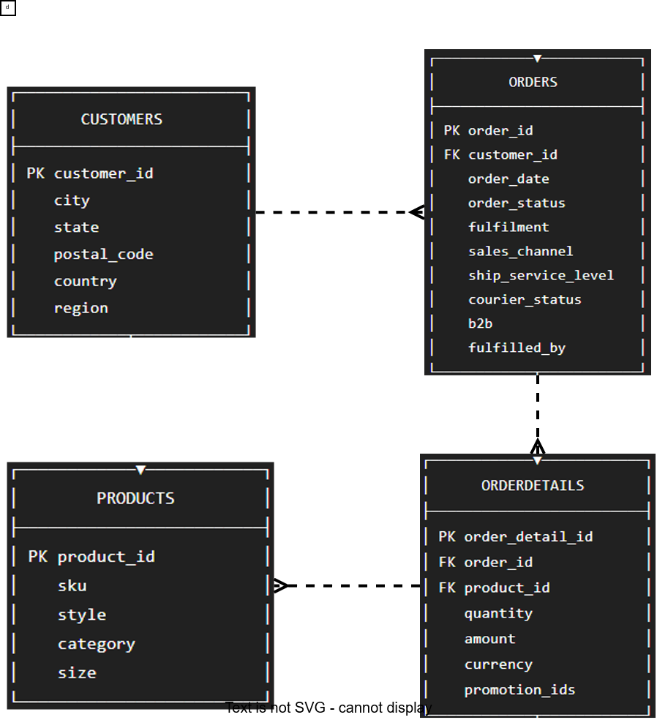

Task 1 : Top-selling product by month.

Solution query:

with monthly_saled as (
select year(o.order_date) as year, month(o.order_date) as month, p.sku, p.category, sum(od.quantity) as total_quantity_sold
from orders o join orderdetails od on o.order_id = od.order_id
join products p on p.product_id = od.product_id
group by year(o.order_date), month(o.order_date),p.sku,p.category
),

ranked_products as (
select year, month, sku, category, total_quantity_sold, rank() over(partition by year, month order by total_quantity_sold desc)
as sales_rank from monthly_saled
)
select year, month, sku, category, total_quantity_sold from ranked_products where sales_rank = 1 order by year, month;

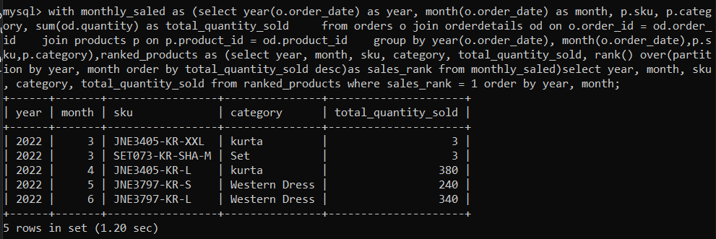

Task2 : Sales by region using JOIN + GROUP BY.

Solution query :

select
c.region, count(o.order_id) as total_orders,
round(sum(od.amount), 2) as total_amount
from customers c join orders o on c.customer_id = o.customer_id
join orderdetails od on o.order_id = od.order_id
group by c.region;

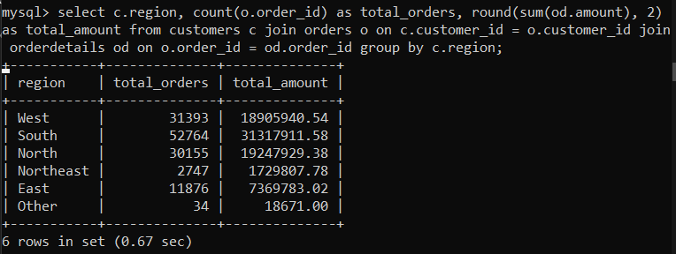

Task 3 : Customers with total spend > threshold (use subqueries). (threshold as 100000)
Query :
select
c.customer_id, c.city, c.state, c.region, ( select sum(od.amount)
from orders o join orderdetails od on od.order_id = o.order_id
where c.customer_id = o.customer_id) as total_spend
from customers c where ( select sum(od.amount)
from orders o join orderdetails od on o.order_id = od.order_id
where c.customer_id = o.customer_id) > 100000
order by total_spend desc;
without subquery :
SELECT
c.customer_id,c.city,c.state,c.region,
SUM(od.amount) AS total_spend
FROM customers c JOIN orders o ON c.customer_id = o.customer_id
JOIN orderdetails od ON o.order_id = od.order_id
GROUP BY c.customer_id,c.city,c.state,c.region
HAVING SUM(od.amount) > 100000
ORDER BY total_spend desc;
